Types of Stands
Corner

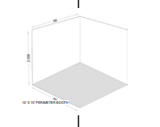 | Corner Stands – These are the end stand in a row of linear stands. They will have two open sides. The same guidelines apply as above however we would suggest the side next to the aisle should remain open to allow for maximum exposure. The standard height of 2.5m (8ft) is allowed along the back wall and each side.  You may display hanging signs, logos and graphics if they are set back 1.0 meters from any side, and you have gained permission from the Organiser. No advertising or logos should directly overlook any neighbouring stand.

